### Adobe Photoshop CS5 Chapter 1 – Test Notes

1. Using Photoshop you can repair and restore damaged areas on images, create and combine images, and create special effects for the Internet.
2. Photoshop is a powerful tool for communicating ideas visually.
3. An irreversible process used to reduce the size of Photoshop files is called flattening.
4. The lasso tool can be used to outline sections of an image.
5. A logo is a recognizable graphic, color, symbol, or distinct text used by an organization.
6. Adobe Dreamweaver lets you optimize, preview, and animate images.
7. The History Panel tracks recent changes made to an image.
8. In Photoshop you can control the distance between characters, edit type, and create and format text.
9. Photoshop’s unique file format extension is .PSD.
10. You can use the Bridge feature to rate and sort your images.

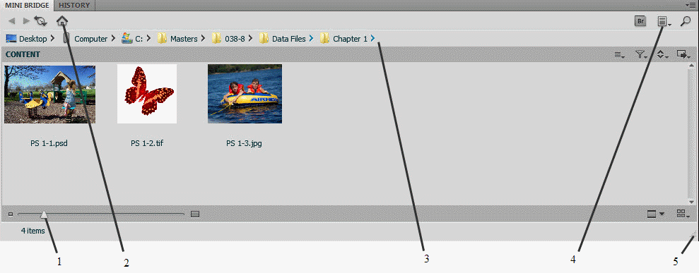

1. In the figure above, figure 2 refers to the button you would click in order to return to the home page.
2. In the figure above, figure 3 refers to the Path bar.
3. In the figure above, figure 4 refers to the Panel View button.
4. In the figure above, figure 5 refers to the area you would drag in order to resize the Mini Bridge window.

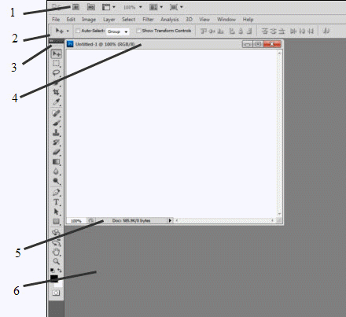

1. In the figure above, figure 3 refers to the Tools panel.
2. In the figure above, figure 2 refers to the Options bar.
3. In the figure above, figure 1 refers to the Application controls.
4. In the figure above, figure 5 refers to the status bar.
5. The Save As command does not modify the original file.
6. The Tools panel in Photoshop contains frequently used tools.
7. The History panel lets you undo or redo recorded actions a needed.
8. The File menu is used to close a file.
9. Standard Full Screen Mode is NOT a mode for viewing menus, panels, and tools in Photoshop.
10. To open the Preferences dialog box, click Edit (Win) or Photoshop (Mac) on the Application bar, point to Preferences, then click a topic that represents the settings you want to change.
11. In design, Tone uses light and shadows to focus the eye and control the mood.
12. A Web designer should not be concerned about Influence.
13. The Fair use doctrine allows a user to make a copy of all or part of a work, even if permission has not been granted.
14. The Attribution Non-Commercial Creative Commons license gives permission for your work to be distributed, modified, or enhanced, with credit to you, for noncommercial purposes only.
15. The Attribution No Derivatives Creative Commons license gives permission for your work to be distributed by others, but not modified and in its entirety, with you being credited.